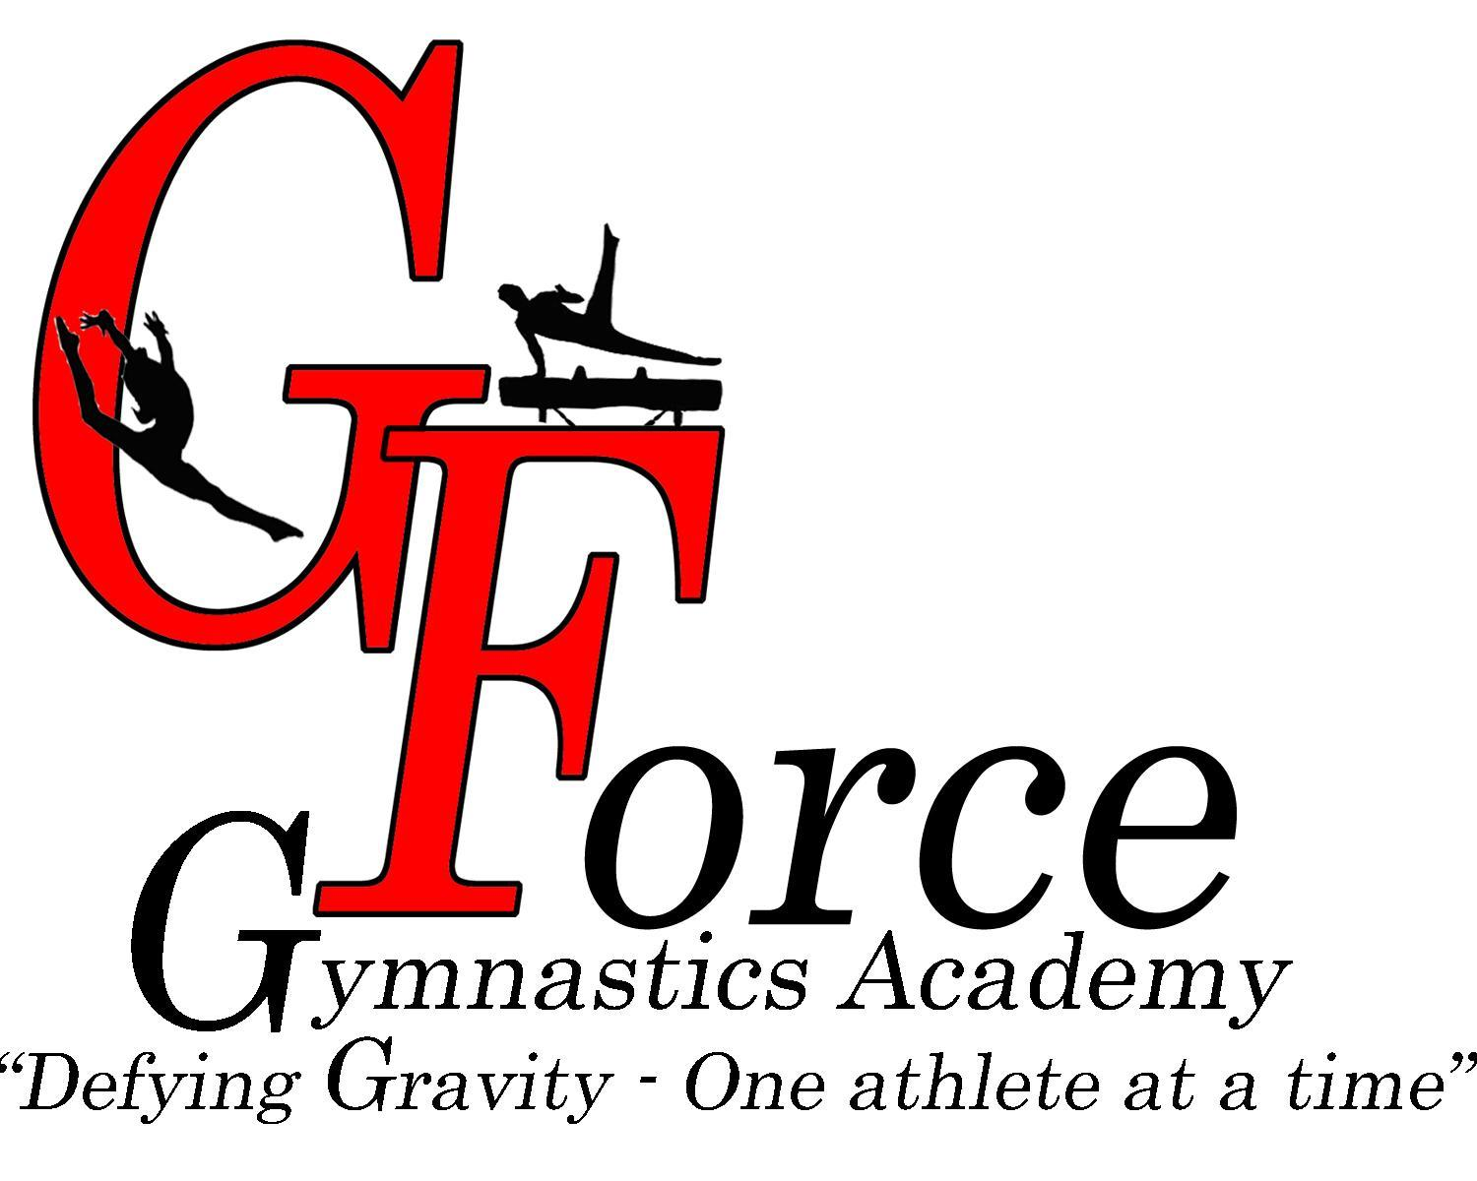
4487 Irving Blvd NW
Albuquerque, NM 87114
505.898.7334
505.898.5534 fax

Dear Valued Business Owner,

I am currently a gymnast at G-Force Gymnastics Academy. Gymnastics training is year-round, and I am getting ready for the next competitive season which includes a tough summer of pre-season training. The athletes are fundraising for the 2022-2023 competitive season and are reaching out to local businesses that may be interested in advertising their business while sponsoring a gymnast. Our parent Booster Association compiles a Year Book that features the businesses supporting these local gymnasts. Each gymnast will receive 100% of the contribution from the sponsor and the sponsor will receive a tax-deductible advertisement. The advertising comes in the form of a full-page in the Year Book, their logo on our banner hung in the gym and mention on our meet score cards (the cost is $100 for a full page and $50 for a half-page ad). Each team athlete will receive a copy of the Year Book to share with their family and copies are available inside the gym to view.

The Advertising will be seen by over ~600 families across Albuquerque and the state of New Mexico at our home gymnastics meet and will be shared with all of the families that are current members of our gym.
As we all know, there are many lessons learned by children and adolescents involved in competitive athletics that go beyond the specific sport they are training. Athletes tend to have higher grade point averages, higher graduation rates, and lower chances to become involved with alcohol or drugs. We would love to feature your business as a business that supports the life lessons that are learned through athletics.

Thank you so much for your willingness and consideration to sponsor me and my athletic endeavors! Your tax-deductible donation is greatly appreciated.

Please make sponsorship checks out to: DDBAI – Desert Diamonds Booster Association Inc. Please provide the name of the athlete you are sponsoring and your e-mail address on the memo line of your check, so upon receipt of your payment, DDBAI can e-mail you your tax receipt and we can direct the funds to the appropriate athlete.

Sincerely,

G-Force Team Athlete

